**ASSIGNMENT**

**MODULE – 1 ( FUNDAMENTALS )**

**Q-1 :- What is SDLC ?**

**->** Full Form Software Development Life Cycle (SDLC) is a structured process that enables the production of high quality, low cost software, in the shortest possible production time.

**Q.2 :- What is software testing ?**

**->**  Software Testing is a process used to identifty the correctness , completeness , and quality of developed computer software.

**Q.3 :- What is agile methodology ?**

**->** Agile is an iterative approach to project management and software development that helps teams deliver value to their customers faster and with fewer headaches.

**Q.4 :- What is SRS ?**

**->** full Form software requirement specification a document that describes what the software will do and how it will be expected to perform.

**Q.5 :- What is oops ?**

**->** Full Form Object Oriented Pragramming is computer programming model that organizes software design around data or objects rather than function and logic.

**Q.6 :- Write Basic Concepts Of Oops ?**

**->** 1. Object

2. Class

3. Abstraction

4. Encapsulation

5. Inheritence

6. Polymorphism

1. Object :- Any Entity Wich Has Own State And Behaviour.

2. Class :- Collection Of Objects Called a Class.

Ex :- Human body

3. Abstraction :- Hiding internal details and showing functionalities.

Ex :- Facebook Login Page

4. Encapsulation :- Warpping up of data or binding of data.

Ex :- Capsule

5. Inheritence :- When one object acquire all the properties and behavior of parent class.

6. Polymorphism :- many ways to perform anything.

Ex :- overloading , overriding

**Q.7**  **What is Object ?**

**->** Objects are the things you think about first in designing a program and they are also the units of code that are eventually derived from the process.

**Q.8 What is Class ?**

**->** A group of students meeting regularly to study the same subject the period during which such a group meets.

**Q.9 What is encapsulation ?**

**->** Mechanism of combining more than one data members and member function that implement on those data members into a single unit.

**Q.10 What is inheritance ?**

**->**  Inheritance in oop when a class derives from another class.

**Q.11 What is polymorphism ?**

-> Polymorphism programming a describes situation in which something occurs in several different forms.

**Q.12 Draw Usecase On Online Book Shopping ?**

**->**

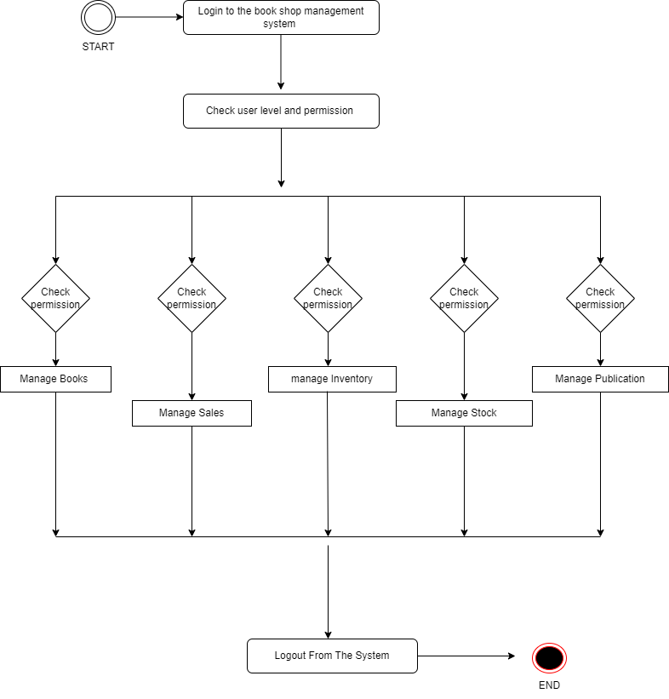

**Q.13 Draw Usecase On Online Bill Payment System (paytm)**

**->** 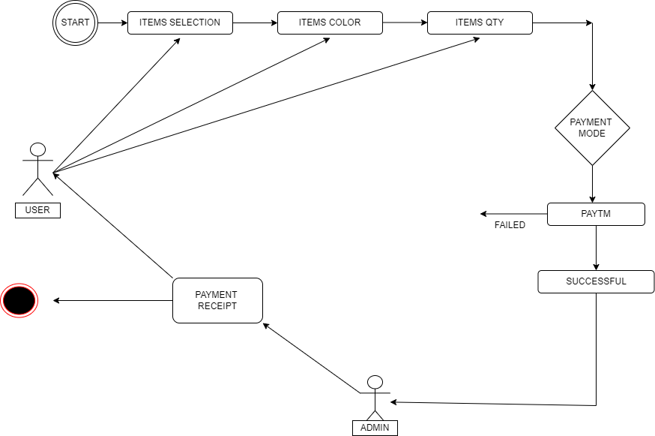

**Q.14** **Write SDLC Phases With Basic Inteoduction ?**

**->** Inception phase (analysis of the project’s needs, goals, and scope) Elaboration phase (the design of a functional product architecture) construction phase (coding of the architecture and creation of a deployable product) transition phase (releasing the product to a production environment

**Q.15 Explain phases of waterfall model ?**

**-> The waterfall is unrealistic for many reasons, especially**

**\* Requirements must be “FORZEN” to early in the life cycle**

**\* Requirement are “ VALIDATED ” too late.**

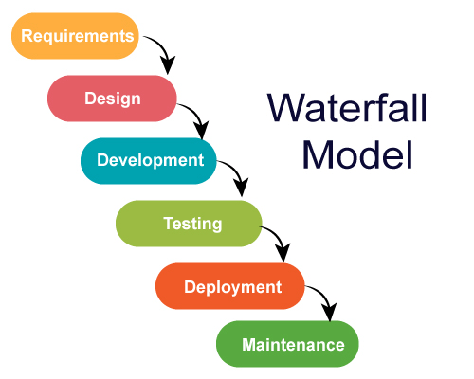

**Q.16 Write phases of spiral model ?**

**->**

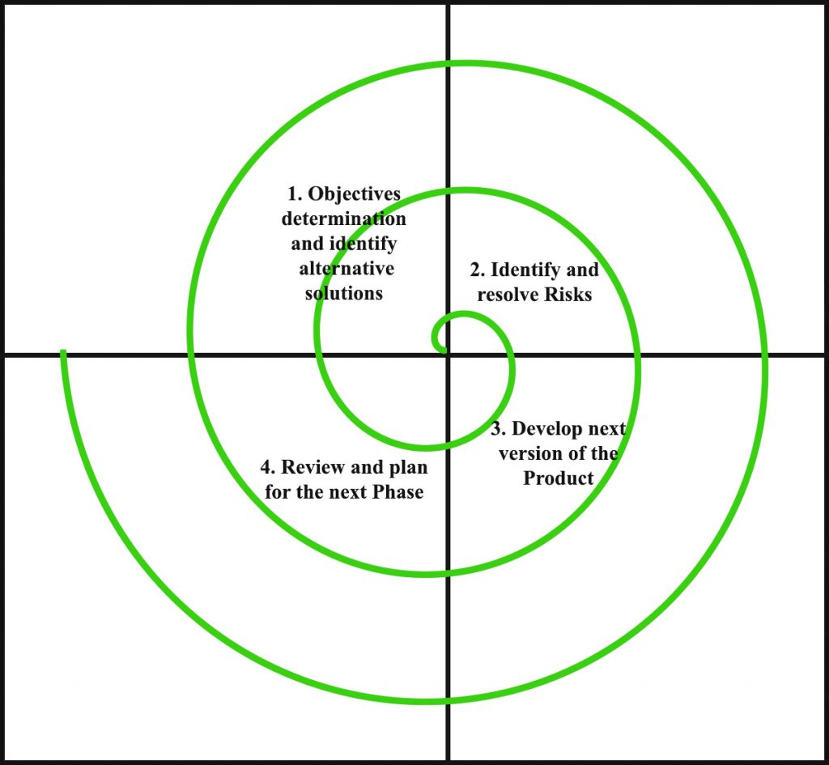

Spiral model is very widely used in the software industry as it in synch with the natural development process of any product.

# long-term project commitment because of potential changes.

# for medium to high – risk project

# Pros ( why it works) :-

1. Changing requirement can be accommodated
2. Users see the system early
3. Allows for extensive use of prototypes

# Cons ( why it doesn’t work):-

1. Management is more complex.
2. Process is complex
3. Spiral may go indefinitely

**Q.17 Explain working methodology of agile model and also write pros and cons ?**

**# Pros #**

**->** Is a very realistic approach to software development

-> Little or no planning required

-> Easy to manage

-> Give flexibility to developers

**# Cons #**

1. No suitable for handling complex dependencies
2. There is very high individual dependency since there is minimum documentation generated.

**Q.18 Draw Usecase on online shopping product using payment gateway ?**

**->**

